**Homework 1 - Section 1 – Relationships**

1) Open Tableau Desktop/Public App and connect to “**Homework_1_Bookshop.xlsx**”

* Use the below diagram to create and **matching field** notes to create the bookshop data model using **relationships**. (note – initial Book join needs to be done in **physical layer**)

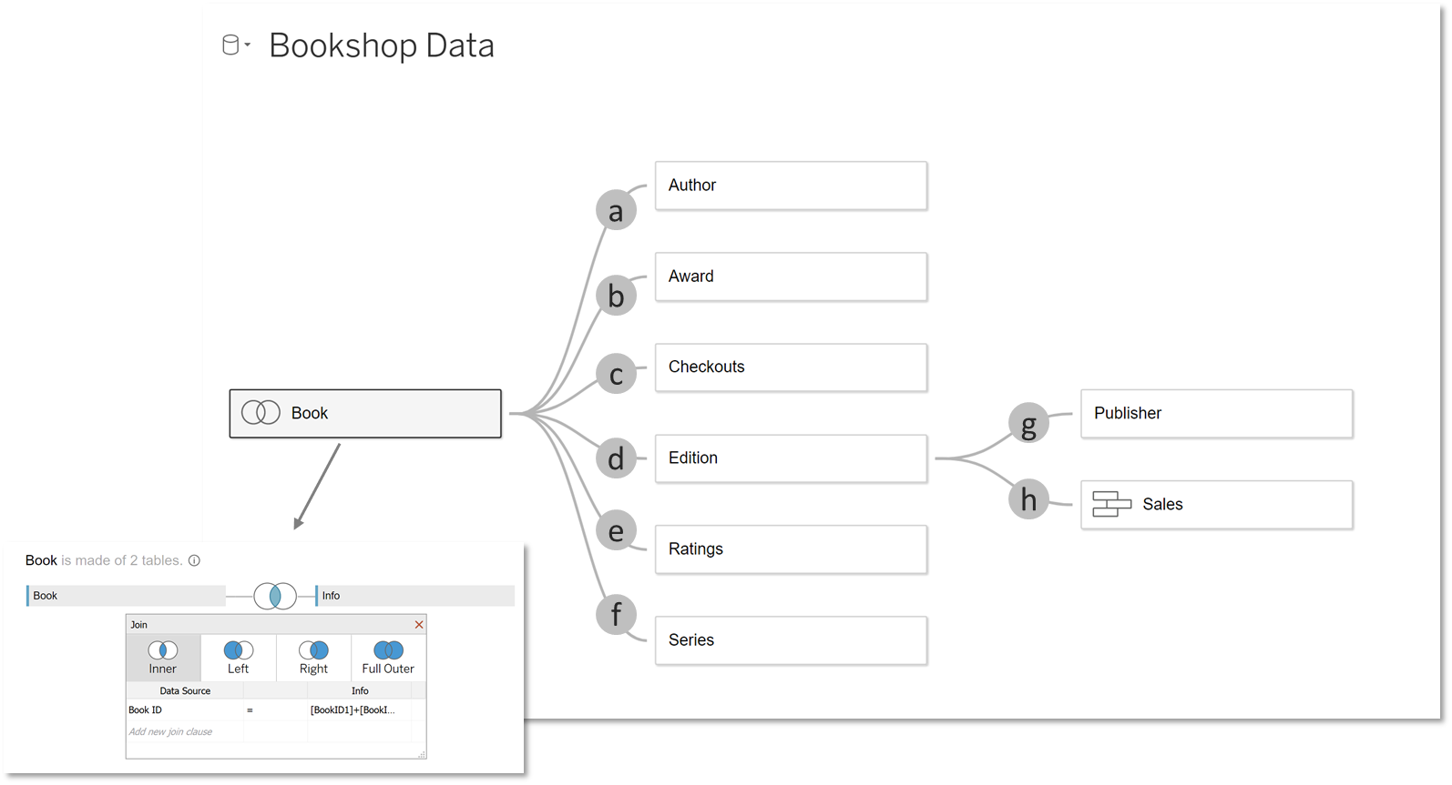

1. Author ID = AuthID
2. Title = Title
3. Book ID = Book ID
4. Book ID = Book ID
5. Book ID = Book ID
6. Series ID = SeriesID
7. Pub ID = PubID
8. ISBN = ISBN (union the 4 sales tables)

2) Create new sheet and name it “**Remain**”

* Make a bar chart with [**Author Name**] and [**Book (Count)**]
* Sort **Descending**

3) Create new sheet and name it “**Represent**”

* Make a bar chart with [**Author Name**], [**Book (Count)**], and [**Number of Checkouts**]
* Show labels and make it so [Number of Checkouts] shows zero for nulls

4) Create new sheet and name it “**Relevant**”

* Create a text table with [**Author Name**] and [**Award Name**]

5) Create new sheet and name it “**Retain**”

* Create a bar chart with [**Author Name**], [**Award Name**] and **[Book (Count)]**
* Make [**Author Name**] before [**Award Name**]

6) Create new sheet and name it “**Recover**”

* Duplicate “Retain” sheet and add [Author (Count)] to the view

7) Create new sheet and name it “**Removed**”

* Create a bar chart with [Title] and [Rating] and sort descending
* Show labels and apply [Genre] to color
* Filter on [Ratings] greater than at least 1

8) Create new sheet and name it “**Replicate**”

* Create a bar chart with [Author Name], [Format], [Ratings (Count)]
* Show labels and sort descending

9) Create new sheet and name it “**Resolve**”

* Duplicate “Replicate” sheet and add subtotals

**Homework 2 - Section 2 – Dynamic Design**

1. Open workbook **Homework_2_Dynamic_Design_Starting_Point** in Tableau Desktop / Tableau Public App.

* Delete **text title box** at top of dashboard
* Hide **titles** on each of the **BAN** **sheets** (BAN – Role Count, BAN – Company Count, BAN – Salary Low Median, BAN – Salary High Median)
* Drag **image object** **floating** onto the dashboard. Choose .png file named “**Homework_Section_2_Dynamic_Design_Background_Template**” and press “OK”.
* Position image **at X – 0 , Y – 0, W – 1400, H – 1400** on the layout tab. Select carrot for image and choose floating order of “**Send to Back**”

1. Create **parameter** called “**Select Dimension**”

* Parameter should be **integer type** and have a list of **3 options**:
  + Industry
  + Sector
  + State
* Create a **calculated field** named “**Multi-Dimension**” and type the below calculation

CASE [Select Dimension]

WHEN 1 THEN [Industry]

WHEN 2 THEN [Sector]

WHEN 3 THEN [State]

END

* Replace **[Sector]** field on rows with new **[Multi-Dimension]** field
* Sort **[Multi-Dimension]** by **[Salary – Low]**
* Change **[Multi-Dimension]** font to **white** and **left align**
* On “Roles in Analytics” dashboard show **[Select Dimension]** parameter, place at **X – 531, Y – 526, W – 144, H – 24** and remove **title**
* Change dashboard **background** to “**None**” (hint – found in Dashboard > Format sub-menu)

1. Create a **parameter** called “**Select Measure**”

* Parameter should be **integer type** and have a list of **3 options**:
  + 1 Company Count
  + 2 Median Salary Low
  + 3 Median Salary High
* Create a **calculated field** named “**Multi-Measure**” and type the below calculation

CASE [Select Measure]

WHEN 1 THEN [Company Count]

WHEN 2 THEN MEDIAN([Salary - Low])

WHEN 3 THEN MEDIAN([Salary – High])

END

* Replace **[Salary - High]** field on color with new **[Multi-Measure]** field on “Map – City” and “Map – State” sheets

1. Create a **parameter** called “**Select Sheet**”

* Parameter should be **integer type** and have a list of **2 options**:
  + 1 State Map
  + 2 City Map
* Create a **calculated field** named “**Display Map**” and place [**Select Sheet**] parameter inside
* On Dashboard > Drag **horizontal container** out to **X – 732, Y – 560, W – 615, H – 306** (hint – move your existing map out of the way first!)
* Place “**Map – State**” and “**Map – City**” in horizontal container and remove **titles**
* Filter on [**Display Map**] field on “**Map – State**” and “**Map – City**” sheets (Map – State should be set to 1 and Map – City set to 2)
* On Dashboard > Show [**Select Sheet**] parameter and place at **X – 1210, Y – 526, W – 144, H – 24**, remove **Title**

1. Select **container** at top of page (hint – it has filters in it already) and show the **container button**

* Position the button at **X – 1347, Y – 12, W – 37, H – 40**
* Assign “**icons8-clear-filters-480.png**” to “**Item Shown**” button
* Assign “**icons8-filter-500.png**” to “**Item Hidden**” button
* Show the [**Select Measure**] parameter to add it to the container
* Rename [**Select Measure**] title to “Measure” and [**Type of Ownership**] title to “Ownership” in filter menu box

1. Create a **parameter** called “**Relative Dimensional Company**”

* Parameter should be **string type** list and should be populated by [**Company**] field
* Create a **calculated field** named “**Selected Company Salary High Diff”** and type the below calculation:

median([Salary - High])

-

max({ FIXED :max(

IF [Company Name] = [Relative Dimensional Company] THEN { FIXED [Company Name]: median([Salary - High])} else null end)})

* On “**Matrix – Company**” sheet replace [**Salary – High**] with [**Selected Company Salary High Diff**] on color mark
* On Dashboard add **Parameter Action** called “**Company Matrix**” with below properties:
  + Source Sheet = Matrix - **Company**
  + Run Action On = **Select**
  + Target Parameter = **Relative Dimensional Company**
  + Field = **Company Name**
  + Aggregation = **None**

1. Create a set off of [**Multi-Dimension**] field and call it “**Asymmetric Set**” (keep all values)

* Color text of field **white** (hint – to see the field, activate the set action by clicking)
* Create a **calculated field** named **\*Click for Company\*** and type the below calculation:

IF [Asymmetric Set] THEN [Company Name] ELSE "" END

* On “**Dumbell Multi-Dim**” sheet add **[*Click for Company\***] to right of [**Multi-Dimension**] on row shelf (widen column a bit)
* On dashboard add a **Set Action** called “**Company Drill-Down**” with the below properties:
  + Source Sheet = **Dumbell Drill-Down**
  + Run Action On = **Select**
  + Data Source = **DataAnalyst**
  + Set = **Asymmetric Set**
  + Running the Action Will = **Assign Values to Set**
  + Clearing the Selection Will = **Remove All Values from Set**
* Color text of field **white** (hint – to see the field, activate the set action by clicking)

**Homework 3 - Section 3 – Geospatial Mapping**

1. Open new workbook and connect to **Homework_3_Geospatial_Mapping_Data** in Tableau Desktop / Tableau Public App.

* Perform a **spatial** **join** between the **Dams** and **Population** tables using an **intersect** equivalency. The join should have a **20’ mile buffer** on the population table side.
* Extract the data

1. Rename “Sheet 1” to “**Radius Map**” and create the below **parameters** and **calculations**:

* Create a **parameter** named “**Buffer Distance**” that is **Float** type and has a default value of **4**.
* Create a **calculation** named “**Buffer Distance Calc**” that creates a **buffer** (in miles) around the [**Latitude**] and [**Longitude**] fields and leverages the [**Buffer Distance**] parameter.
* Create a **calculation** named “**Dam Distance**” that calculates the **distance** from the two sets of **Lat/Long fields** *(hint: these lat/long fields represent the center points of the damns and the population zip data)*
* Create a **calculation** named “**Buffer Filter**” using this calculation: **[Dam Distance]<=[Parameters].[Buffer Distance]**
* Construct a **dual axis map** using [**Latitude1**] and [**Longitude1**] fields, using [**Latitude1**] to facilitate the dual axis.
* The **first axis** should be “**Map**” mark type with [**Buffer Distance Calc**] and [**Dams 00X020**] as part of the **detail**.
* The **second axis** should be “**Map**” mark type with [**Zip Code ZCTA (Population)**] and [**Ndid1**] on **detail**. The [**Hazard**] field should apply on **color** with these settings = (**44% Opacity, High = #c00000, Significant = #ffc000, Low = #8faadc**)
* The below filters should be applied:
  + [**Buffer Filter**] = TRUE (Apply to all sheets)
  + [**State (group)**] = “New England” (Apply to all sheets)
  + [**Dam Type**] = All (Apply to all sheets)
  + [**Dam Name**] = All (Apply to all sheets)
  + [**Hazard**] = All (Apply to all sheets)
  + [**State Name**] = All (Apply to all sheets)
  + [**County**] = All (Apply to all sheets)
* Change map layer to “**Outdoors**” and remove the “**Base**” and “**Country/Region Borders and Names**” options.

1. Create a **new dashboard** and name it “**Dam Risk**”

* Set dashboard size to **1400x1400** and add the background image “Homework_Section_3_Geospatial_Mapping_Background placed at **X – 0 , Y – 0, W – 1400, H – 1400 (Floating)**
* Add floating **horizontal container** at X – 180, Y – 164, W – 1131, H – 35 and place filters in following order in container: [**State (Group**)]…rename to “Area”, [**State Name**]…rename to “**State**”, [**County**], [**Hazard**], [**Dam** **Type**], [Dam Name]. All filters should be relative, Multi-Select dropdowns that are relative and distributed evenly.
* Drag “**Radius Map**” sheet to **X – 89, Y – 334, W – 534, H – 637**
* Drag the **Radius M**ap legend with no title to **X – 196, Y – 995, W – 364, H – 23**
* Drag “**Show Buffer Distance**” to **X – 508, Y – 256, W – 534, H – 637**
* Show the “**Buffer Distance**” (change to Buffer mi) parameter and place it at **X – 508, Y – 256, W – 125, H – 26**

1. Create a new sheet and name it “**Population Map**”

* Add {**RZip Code ZCTA (Population}**. Add [**State**] to detail and [**Population**] to color and set shape to **circle**.
* **Dual axis** the [**Latitude (Generated)**] and set the Mark Type to “Map”. Set the circle color to black
* Go the “**Dam Risk**” dashboard and drag “**Population Map**” and set to **X – 781, Y – 334, W – 534, H – 637**
* Place legend at the bottom of chart at **X – 948, Y – 992, W – 252, H – 27**

1. Create a **new sheet** and name it “**Custom Territory”**

* Add [**County**] and [**State Name**] to detail and set map to “map” style
* Create a **group** off **western Massachusetts** counties and remove the main [**County**] field from detail
* **Fix the error** by renaming to “**Penobscot**” and **hide other indicators**
* Create a **map hierarchy** with the following: **[State (group)], [State Name], [County], [City], and [Zip Code ZCTA]**
* **Bonus** (not required). Create a sheet named “Dam Detail” and make a table using **[State (group)], [State], [County], [Dam Name], [Dam Type], [Purposes], Max([Height]), Max([Age])** and text color using Hazard]. Place this on the dashboard at **X -63, Y – 1063, W – 1281, H – 302**

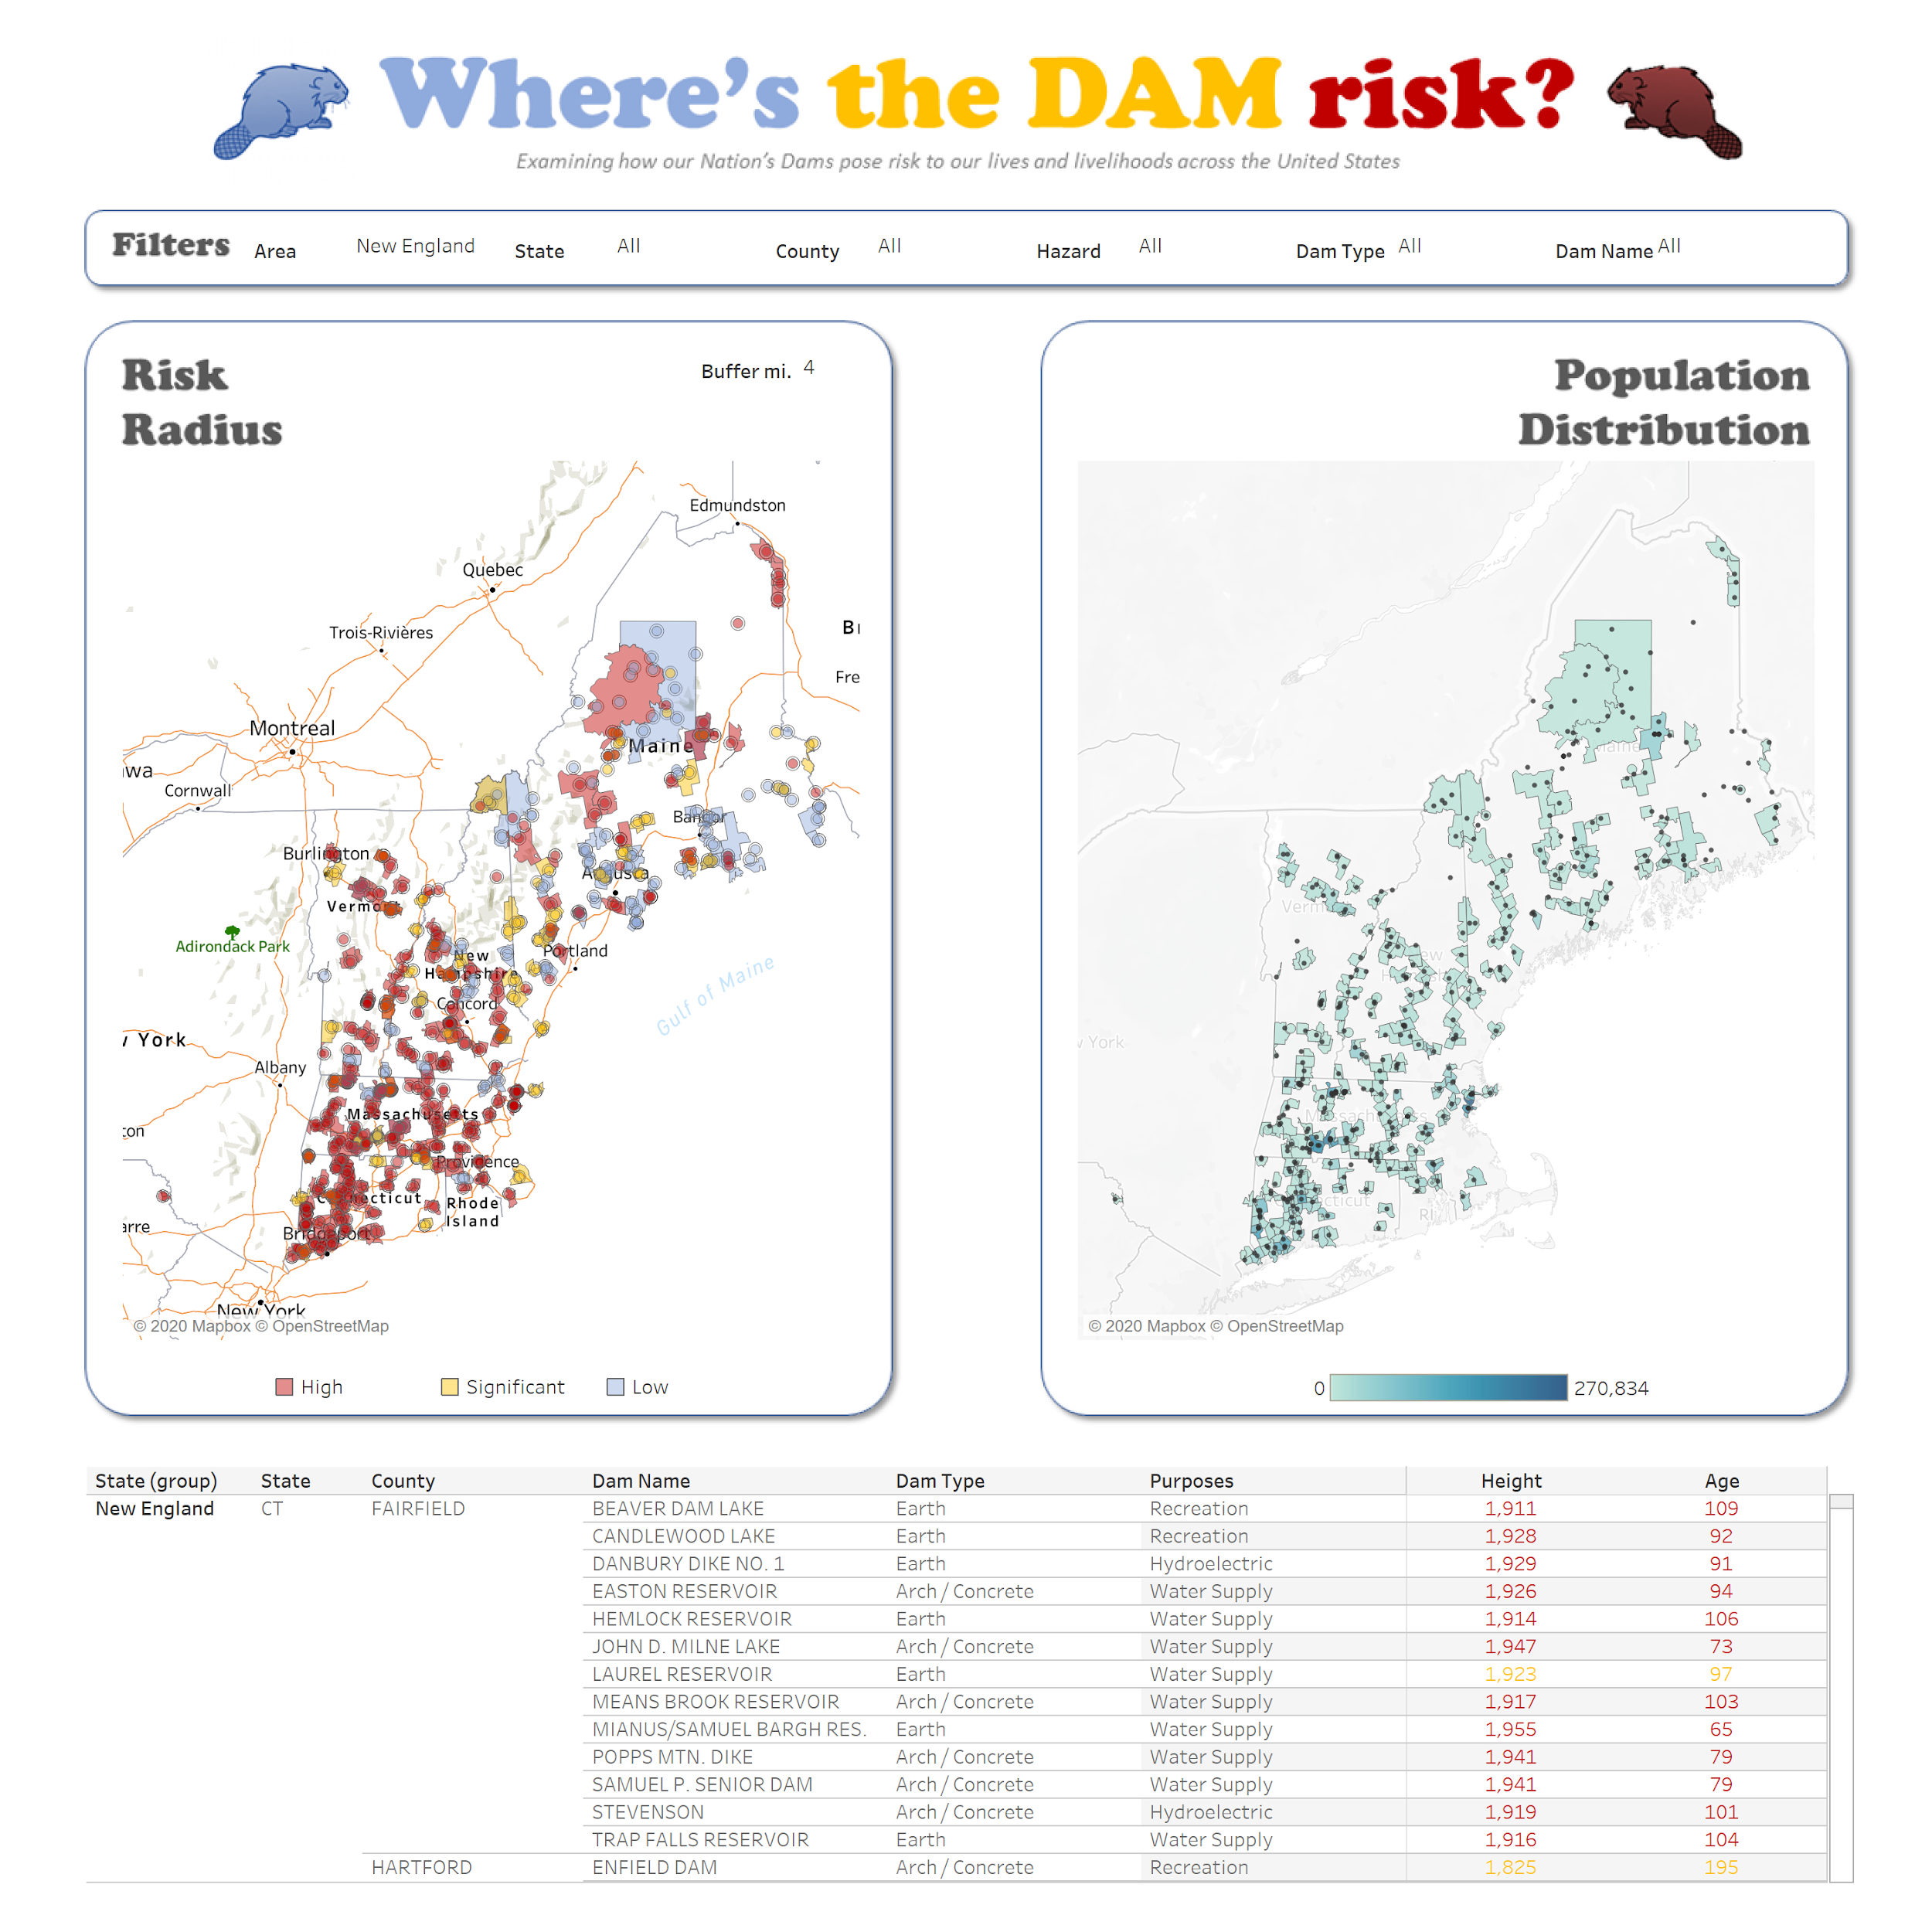

**Homework 4 - Section 4 – Advanced Calculations**

1. Open **Homework_4_Advanced_Calculations_Start** workbook in Tableau Desktop / Tableau Public App.

* Go to “**BAN**” tab, create two **FLAG** fields using **Fixed LODs** to isolate “**This Year**” and “**Prior Year**”, returning a “1” for matching your condition and a 0 otherwise. (example calcs calc below).

**TY FLAG**

IF [Year] = { FIXED :MAX([Year])} then 1 else 0 end

**PY FLAG**

IF [Year] = { FIXED :MAX([Year])}-1 then 1 else 0 end

* Create time-based earnings fields for **TY** and **PY** Total Earnings by multiplying against our new time flags.

**TY Total Earnings**

[Total Earnings]*[TY Flag]

**PY Total Earnings**

[Total Earnings]*[PY Flags]

* Create a **earnings difference** field and a **yoy % difference** field from the time-based earnings fields.

**TY/PY Total Earnings Diff**

sum([TY Total Earnings])-sum([PY Total Earnings])

**YOY Earnings %**

[TY/PY Total Earnings Diff]/sum([PY Total Earnings])

* Place [TY Total Earnings] and [YOY Earnings %] on **Text**. Make [TY Total Earnings] size 68 pt font, # 203d75 blue, and currency format (in billions). Place [YOY Earnings %] below in gray italic 16 pt font and add “v. PY” flat text. Filter **[Department Name**] to **Boston Police Department** (example below).

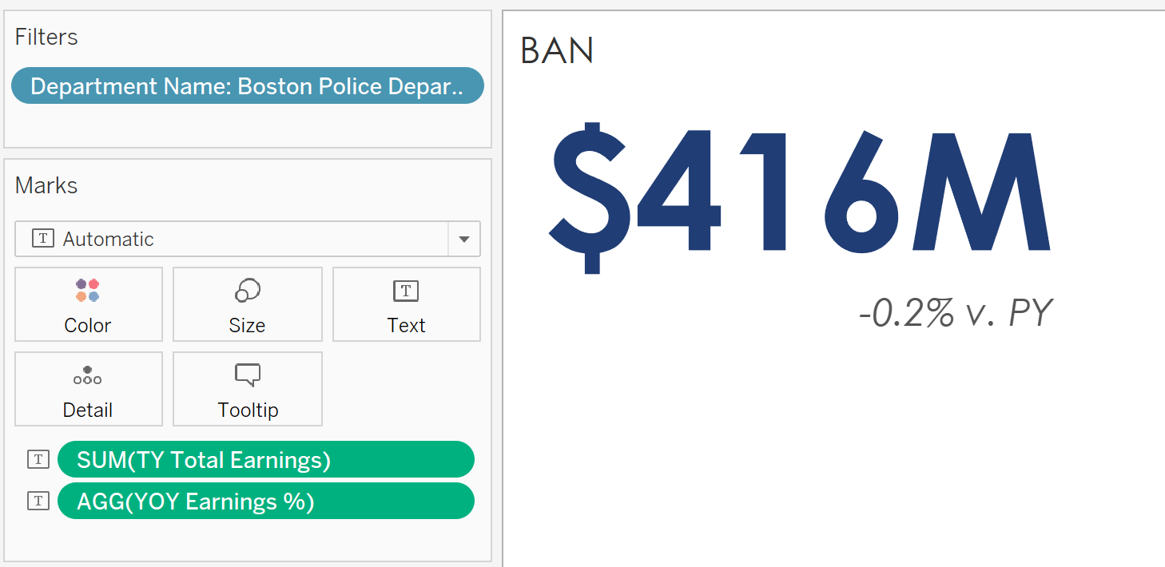

1. Go to “**Police vs. Fire**” tab and create the Fire Department Median and Median Pay CAGR **LOD calculations.**

**Boston Fire Median**

{ FIXED [Year]:MEDIAN(IF [Department Name] = "Boston Fire Department" THEN [Total Earnings] else null end)}

**Median Pay CAGR**

POWER((LOOKUP(MEDIAN([Total Earnings]),last())

/

LOOKUP(MEDIAN([Total Earnings]),first()))

,(1/(max({ FIXED :MAX([Year])}) -

min({ FIXED :MIN([Year])}))

)) -1

* Add **[Measure Values]** and **[Year]** to the view and filter to only [Boston Fire Median] and [Total Earnings] on measure names. Make **[Total Earnings]** aggregate via a Median. Add labels at line ends.
* **Dual-axis** the [Median Pay CAGR] and make the line opacity 0% (so its invisible). **Annotate** a mark at the mid-point of the CAGR line and add the text “BPD CAGR” and the [Median Pay CAGR] value. **Filter** [Department Name] to Boston Police Department (example below).

*Example of Police v. Fire Sheet Below*

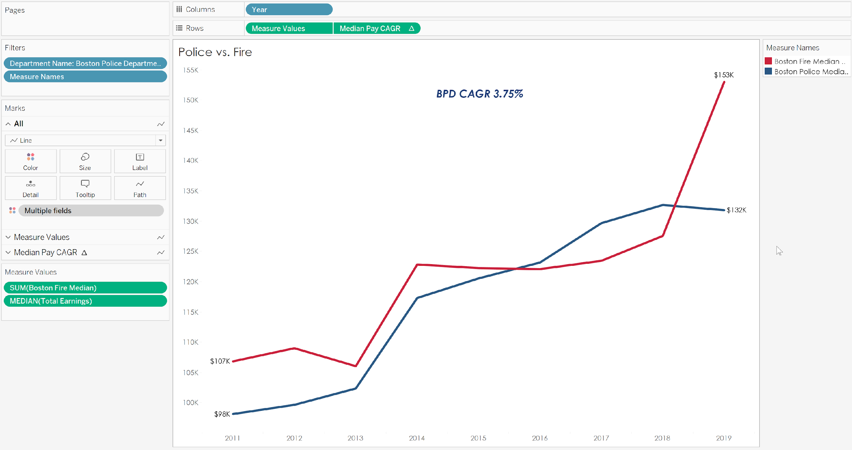

1. Go to “**Police Officer Tenure Cohort”** tab.

* Create a **[Tenure Cohort]** calculation to group individuals by their start year (those **prior to 2011** are grouped together).

**Tenure Cohort**

{ FIXED [Name]:MIN([Year])}

* Create a **cohort line** chart using **[Tenure Cohort], [Year],** and **[Total Earnings]** with **[Tenure Cohort]** applied to the color mark.
* Create a **regular expression** match calculation to identify only those **[Title]** records where “**POLICE**” is mentioned. Call the new field **[Police Officer Match]** and filter to **TRUE** values only

**Police Officer Match**

REGEXP_MATCH(upper([Title]),"POLICE")

*Example of Police Officer Tenure Cohort*

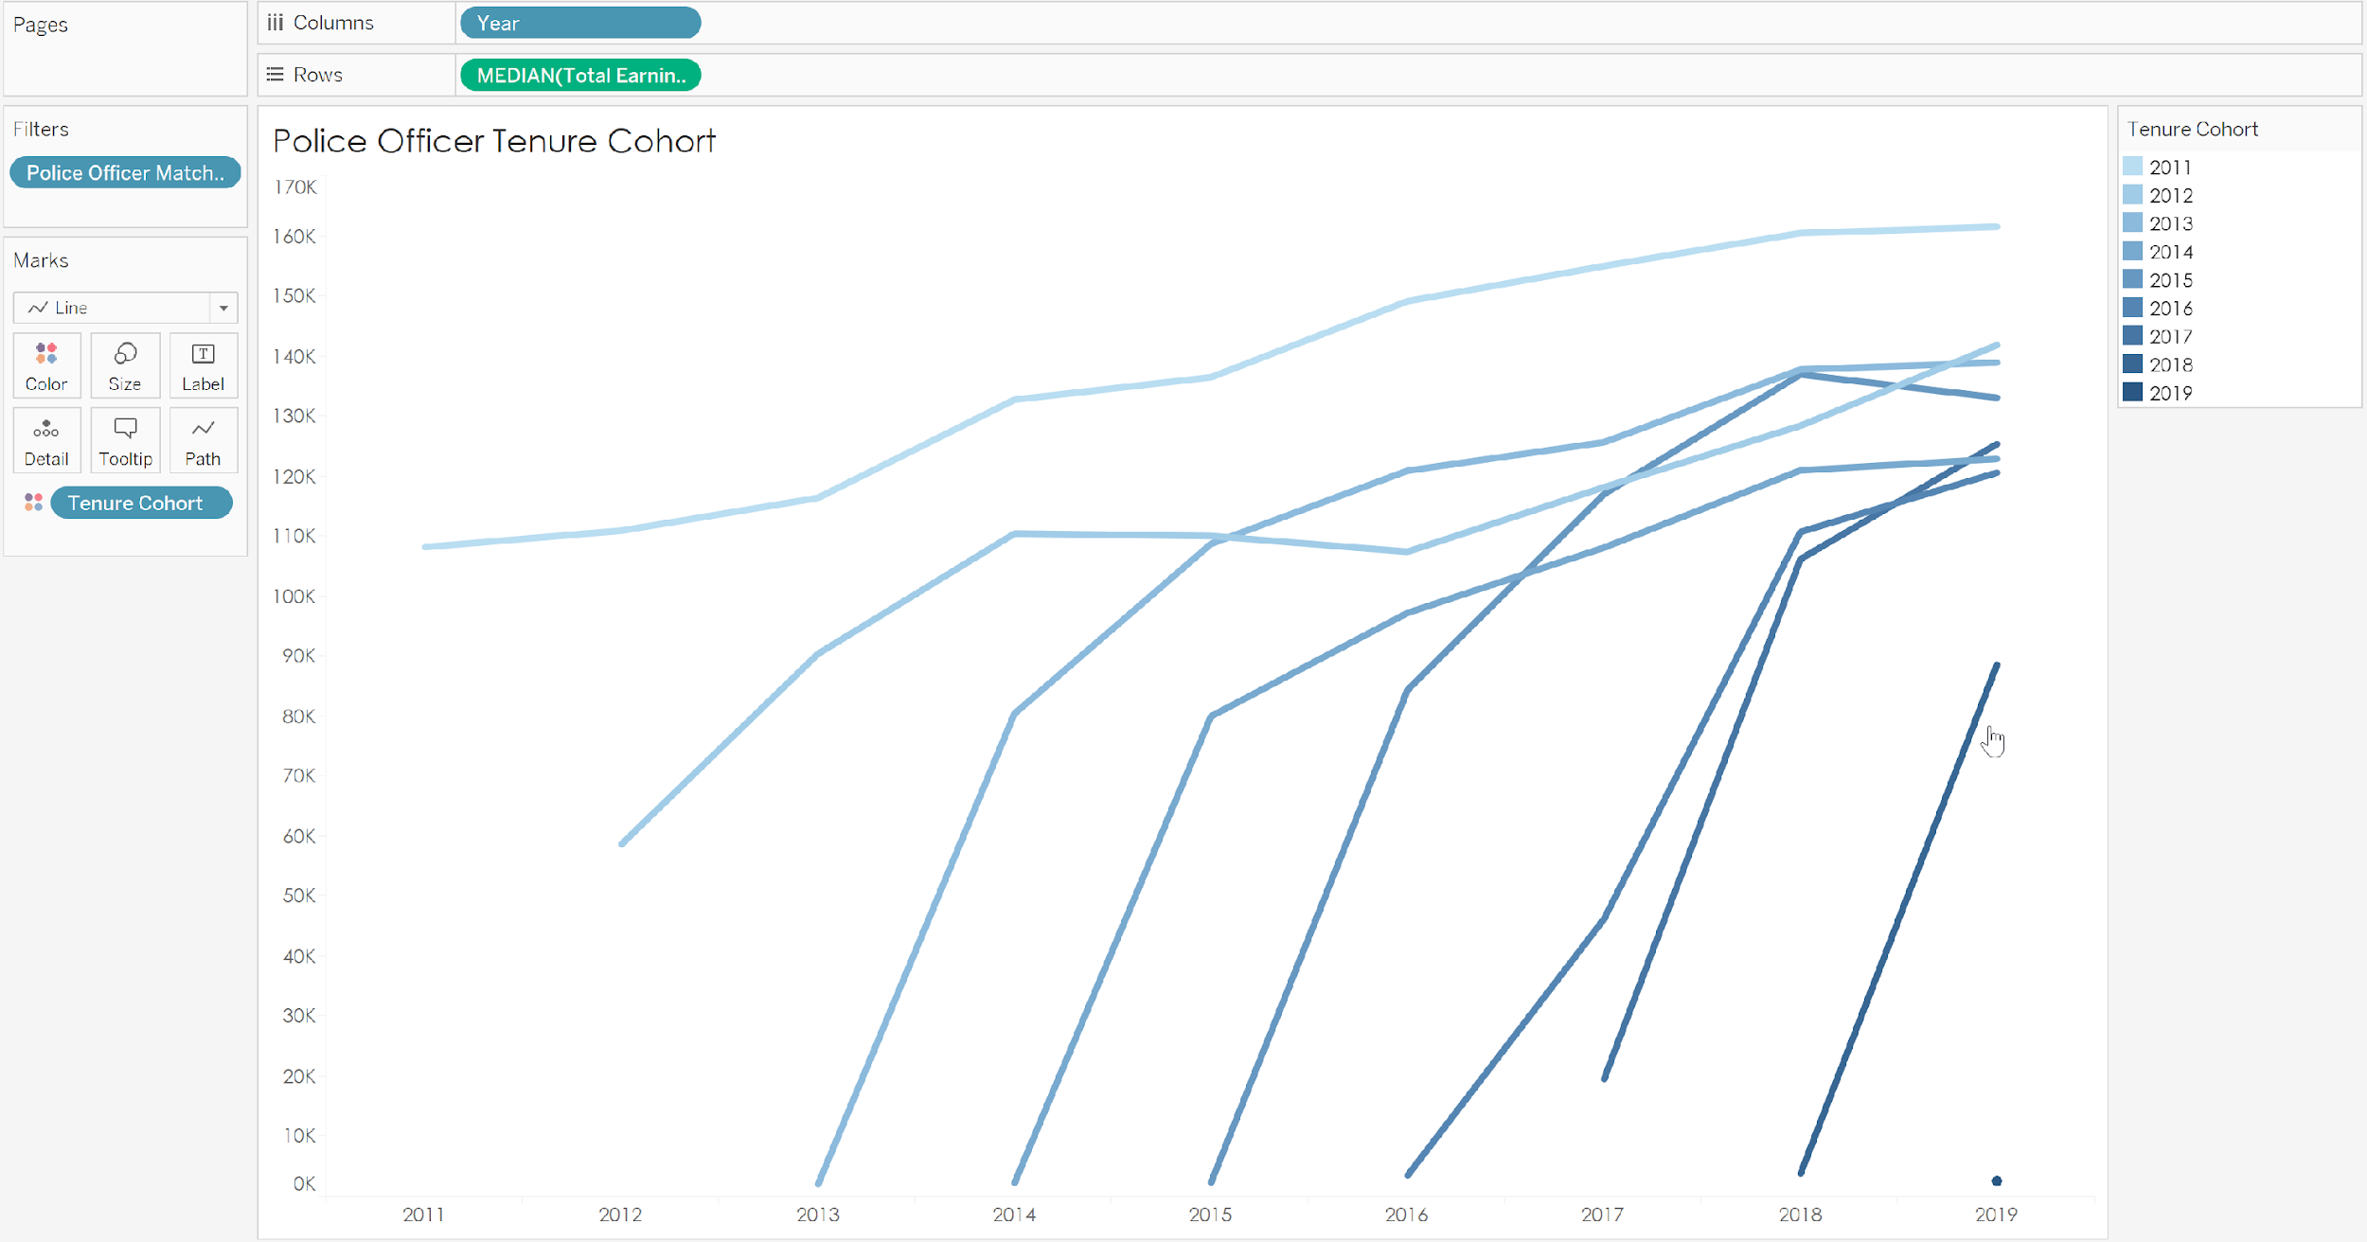

*Example of Full Dashboard*

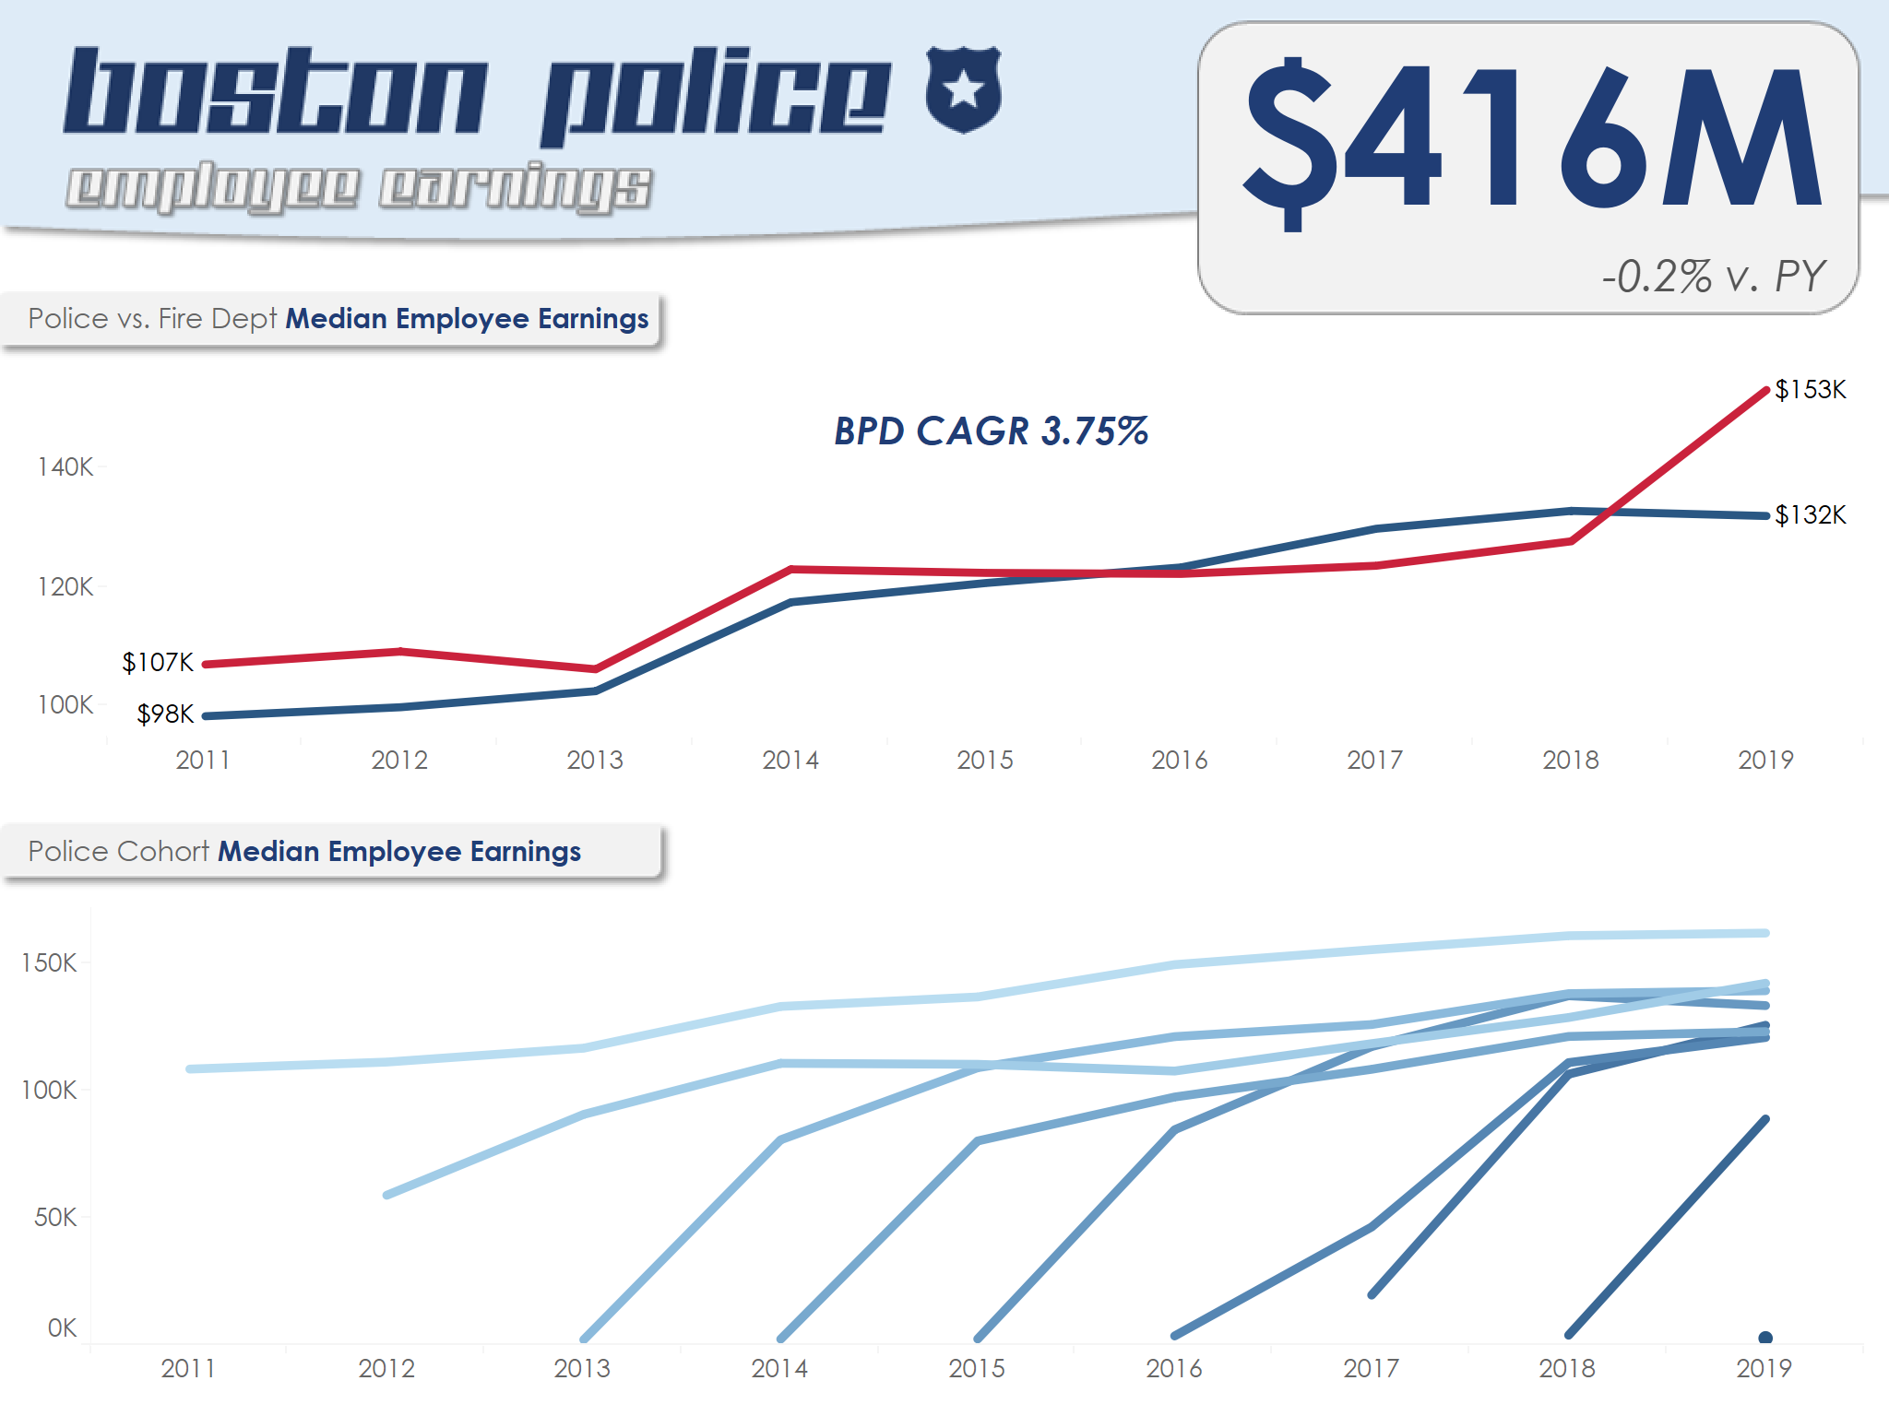

**Homework 5 - Section 5 – Predictive Analytics**

1. Open **Homework_5_Predictive_Analytics_Start** workbook in Tableau Desktop / Tableau Public App. Go to “**Trend Line & Forecast**” tab.

* Create a **line chart** from the **[Year]** and **[Life Expectancy]** fields and **remove zero** from your Y-Axis
* Filter to “**United States of America**” only
* Add a **forecast** to the view and **remove the forecast pill** from the marks card. Modify the line color to be #14abec
* Add a **[Display]** field filter and set to “1”
* Add a **linear trendline** to the view (review P Value and R Squared values generated)

*Example of Trend Line & Forecast*

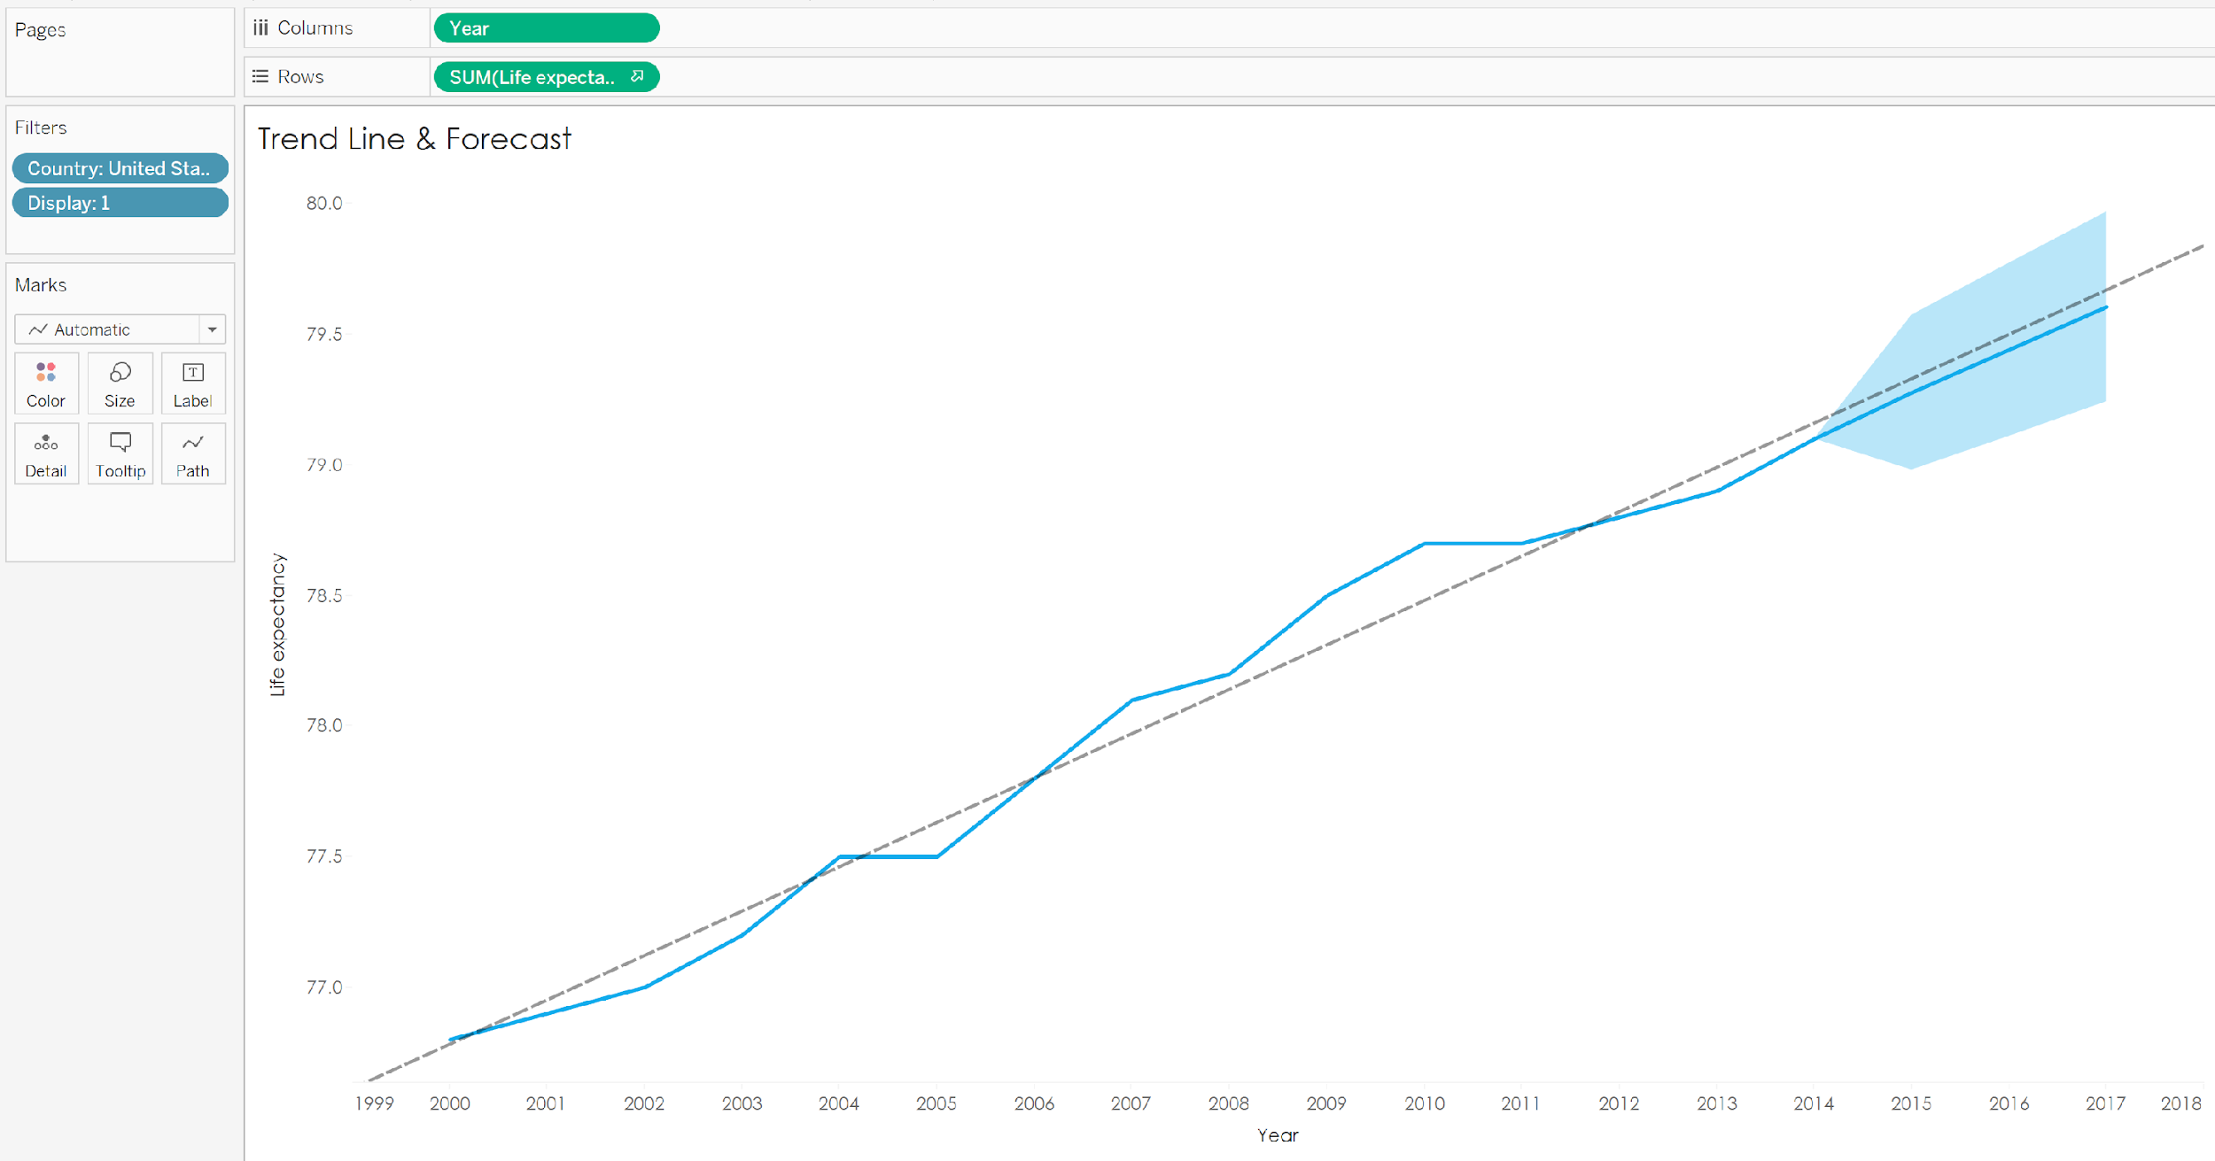

1. Go to **“Control Chart”** tab

* Create a line chart using the **[Year], [Country], [Life Expectancy],** and **[Status]** fields (Note: the **[Country]** field should be on the detail shelf so you have 1 chart with many lines)
* **Remove Zero** from your Y-Axis
* Add a **distribution band** with +/- 3 Standard Deviaitions
* Note **which countries fall beneath** the lower limits – why are they there? (think wars, famine, natural disasters, etc).
* Add a **[Display]** field filter and set to “2”

*Example of Control Chart*

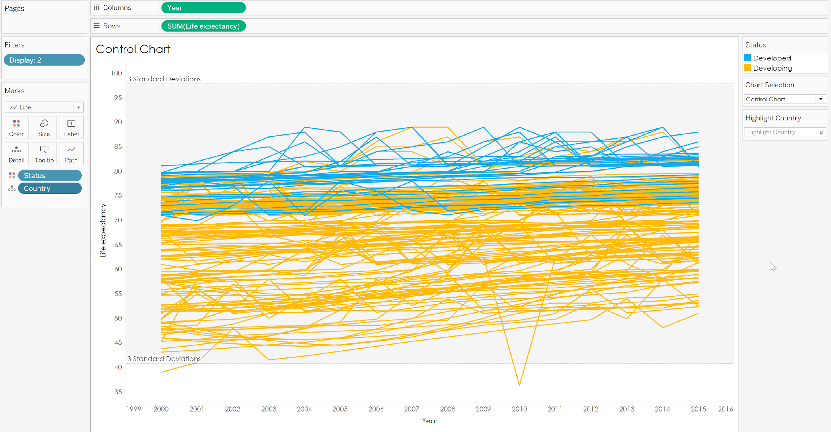

1. Go to **“Clusters”** tab

* Create a **scatter plot** chart using the **[Income Composition of Resources]** and **[Life Expectancy]** fields ([Life Expectancy] should be on rows])
* The fields **[Status], [Year]** and **[Country]** should be added to detail
* The **[Population]** field should impact size (hint – move slider to about 70% of max) and shape should be changed to circle
* Add **clusters** to the scatter plot and add **ALL fields** as variables with the exception of the **[Display]** field
* Clusters should be colored as Cluster 1 = #**14ABEC** , Cluster 2 = #**FFBA0B** , Not Clustered = #**E5E5E5**. Opacity should be **70**% with a dark gray border
* Filter to **[Years] 2010 – 2015** and **“Developing” [Status]** countries only
* Select countries via **tooltip** to see their specific trends for each cluster
* Add a **[Display]** field filter and set to “3”

*Example of Control Chart*

